**Website Requirements**

### **1. Example Sites**

List of websites for style reference:

* https://yallahcoffee.co.uk/
* https://highestco.com/pages/our-coffees?gad_source=1&gclid=CjwKCAjwo6GyBhBwEiwAzQTmc8Mg3LFQkPi5G7BIa0qxPxwEJ1RHC4-LaOCoZeB9Ah4ycz1KYHWutBoCnFUQAvD_BwE
* https://jungleculture.eco/pages/wholesale

### **2. Logos**

Logos in .png format, various sizes:

* XS: 50x50 px



* S: 100x100 px



* M: 200x200 px



* L: 400x400 px

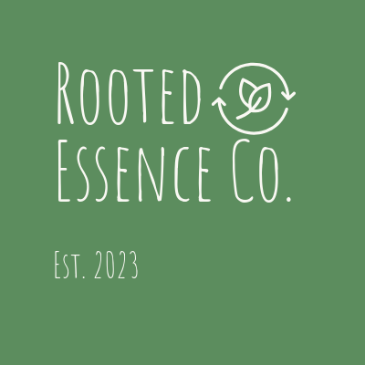

* XL: 800x800 px

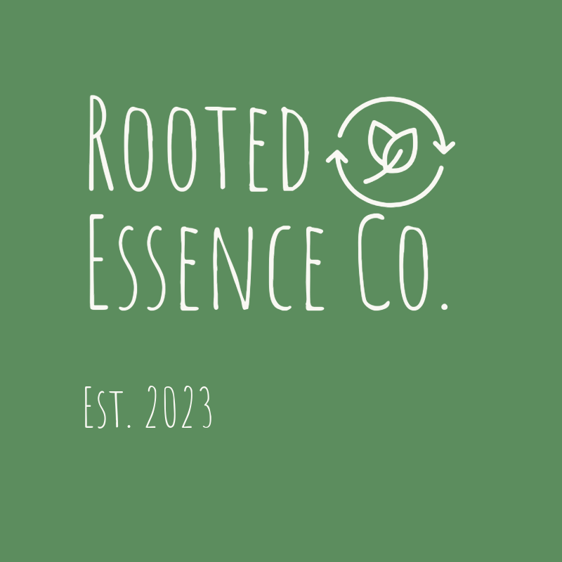

### **3. Logo Font**

Font used in the logo:

* Font Name: Amatic SC Regular
* Font size: 268 and 118

### **4. Photos**

High-quality photos for the website:

Boswellia Carterii Resin

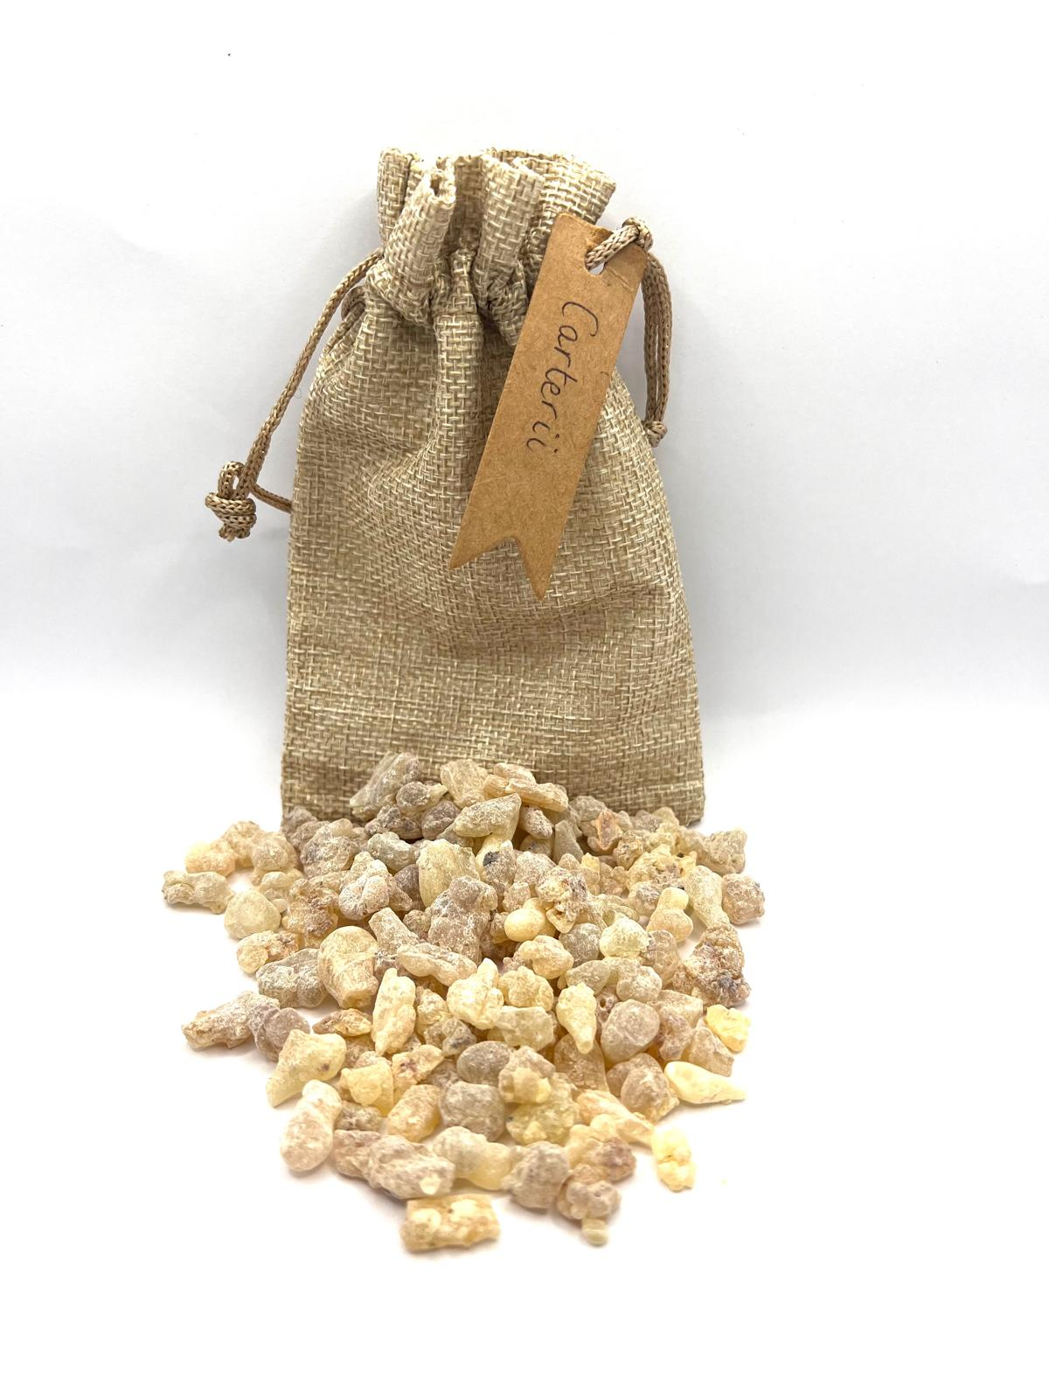

Boswellia Carterii Essential Oil:

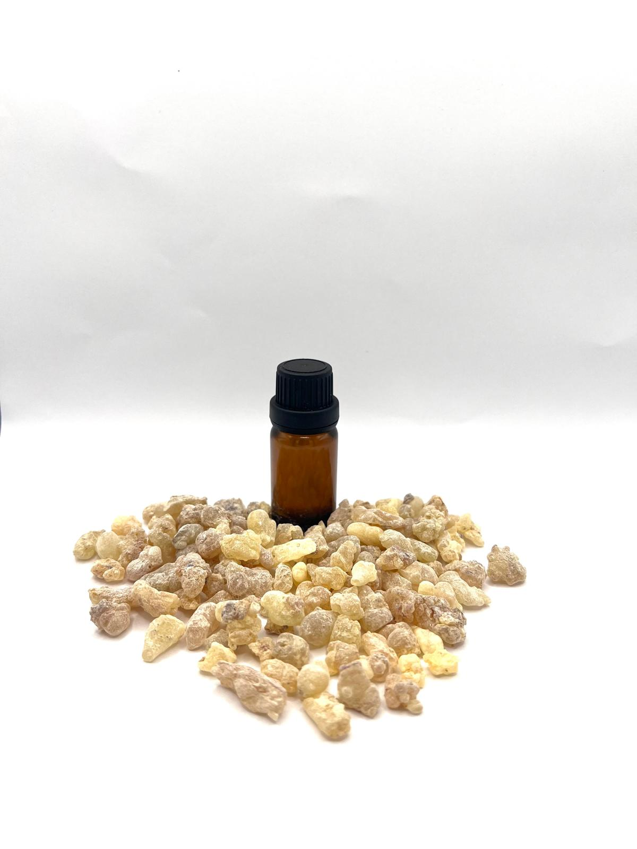

Myrrh Resin:

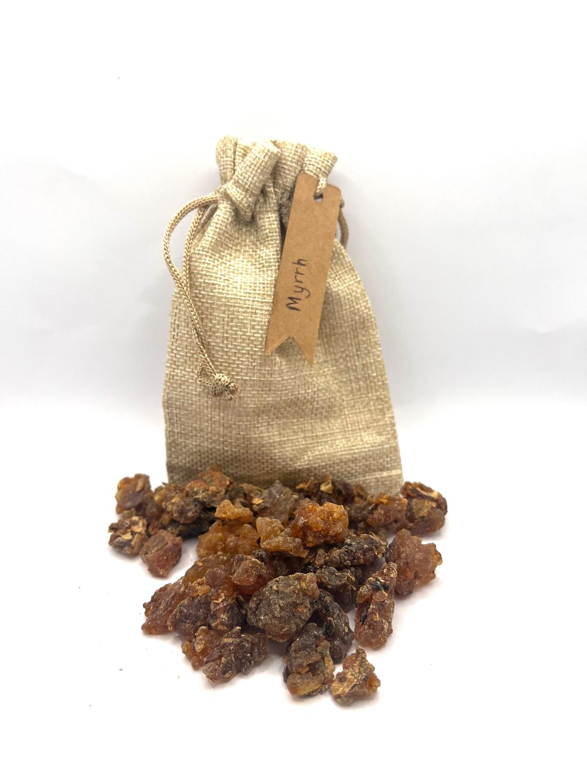

Myrrh Essential Oil:

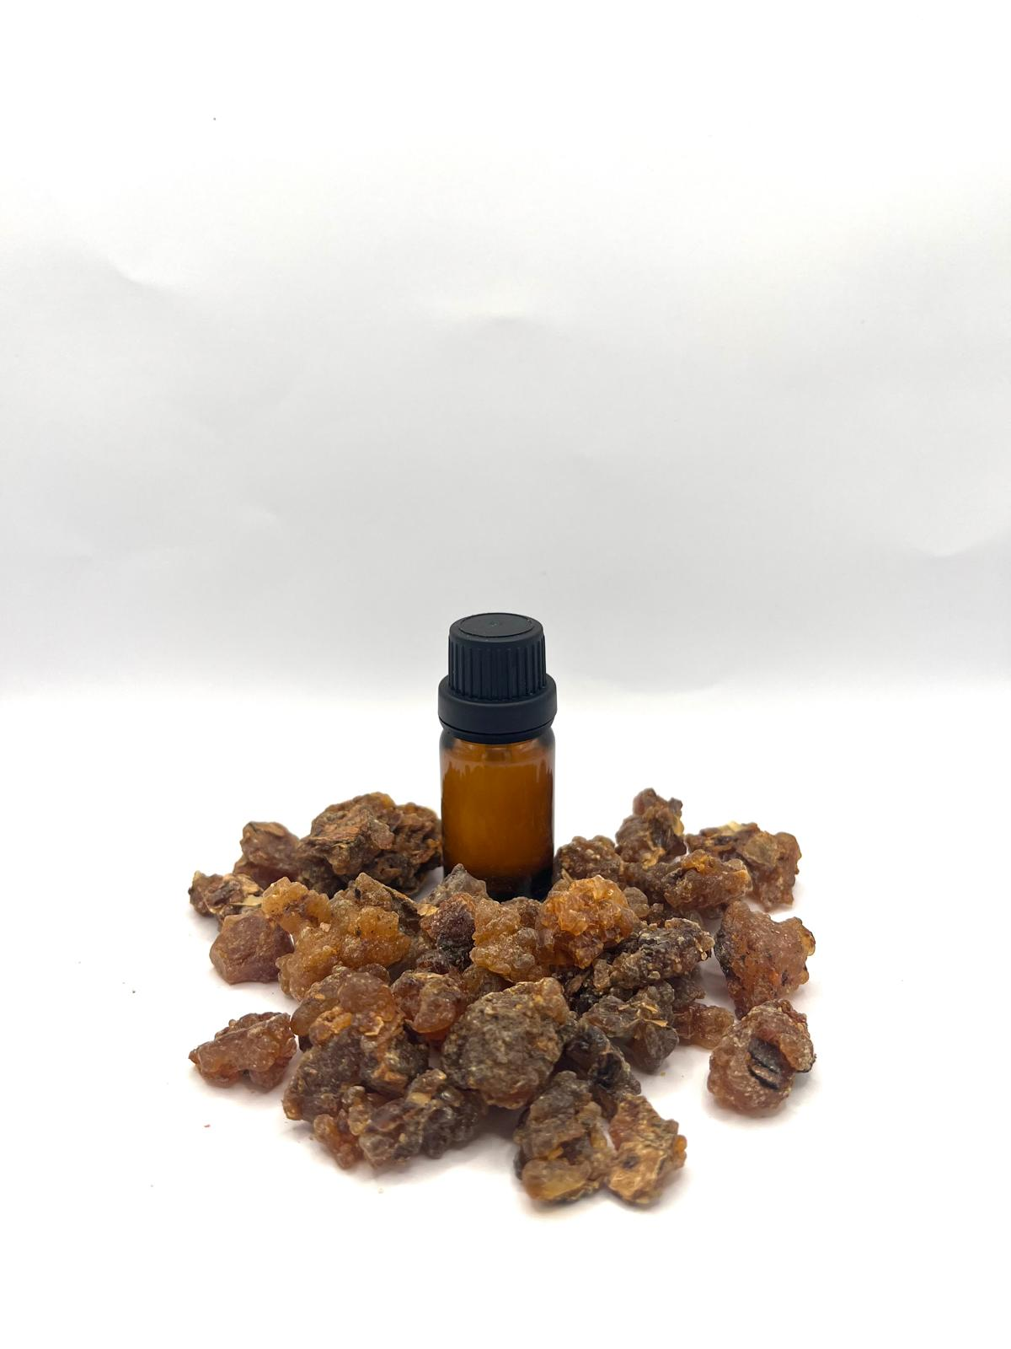

Boswellia Frereana Resin:

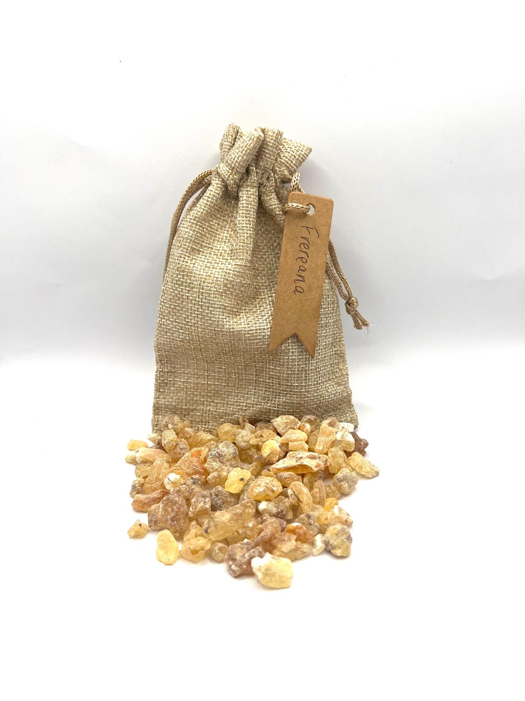

Boswellia Frereana Essential Oil:

